

3S IT Solutions Virtualization Project

Feasibility Report v1.01.

AUTHORS: Nick Bronnikov,
Reynaldo Suarez,
Darrin Hodges.
SUBJECT: Feasibility Report.
TEACHER: Francisco Palma.

Table of Contents

1. Document Summary 3
1.1 Document History 3
1.2 Document Purpose 4
1.3 Document Audience 4
2. Management Summary 5
2.1 Problem analysis 6
2.2 Existing Issues 6
2.3 Potential Issues 6
3. Solution one – VirtualBox 7
3.1 The technical feasibility of the solution. 7
3.2 The economic feasibility of the solution. 7
3.3 The legal feasibility of the solution. 9
3.4 The operational feasibility of the solution. 9
3.5 The schedule feasibility of the solution. 9
4. Solution Two – Hyper V 10
4.1 Technical feasibility 10
4.2 Economic feasibility 10
4.3 Legal feasibility 12
4.4 Operational feasibility 12
4.5 Schedule feasibility 12
5. Solution Three - VMware System Solutions 13
5.1 Technical feasibility of the solution 13
5.2 Economic feasibility 13
5.3 Legal Feasibility. 14
5.4 Operational Feasibility. 15
5.5 Schedule Feasibility. 17
6. Cost and Benefits Analysis 18
7. Outline of approximate budget, timing and risks 20
8. Recommendation 21
9. Appendices 22
9.1 Costs breakdown for solution 1 – VirtualBox. 22
9.2 Costs breakdown for solution 2 – Hyper-V. 24
9.3 Costs breakdown for solution 3 – VMware. 25
10. Glossary 25
11. References 26

Document Summary

Document History
Date | Revised By | Changes Made | Version
11/09/2010 | Darrin Hodges | Initial Document creation. Added Solution 1. | 1.00
11/09/2010 | Darrin Hodges | Added Solution 2 Contributed by Reynaldo Suarez. | 1.00
11/09/2010 | Darrin Hodges | Added Solution 3 contributed by Nick Bronnikov. | 1.00
13/09/2010 | Darrin Hodges | Moved problem analysis from solution 2 to management summary section. Completed document creation, summary and audience sections. | 1.00
15/09/10 | Darrin Hodges | Customized ROI template provided by Reynaldo. | 1.00
20/09/10 | Reynaldo Suarez | Fixed formatting, indexing, spelling and created table of contents. | 1.00
6/10/10 | Nick Bronnikov | Completed Risks/benefits outline | 1.00
7/10/10 | Darrin Hodges | Inserted costs/benefits charts, submitted draft version1.0 to Franco. | 1.00
14/10/10 | Nick Bronnikov | Fixed document formatting, applied right justification to text, fixed document index page. | 1.00
14/10/10 | Reynaldo Suarez | Moved incorrectly placed sections from solution two back to solution 1. | 1.00
18/10/10 | Darrin Hodges | Moved ‘Problem Analysis from Solution 2 to ‘management summary.’ | 1.00
31/10/10 | Darrin Hodges | Corrected draft errors, added appendices for solution ½ costings. | 1.01

Sections by Reynaldo Suarez
- Management Summary
- Solution 2
- Reference/glossary
- Recommendation

Sections by Nick Bronnikov
- Solution 3
- Risks/benefits outline
- Reference
- Glossary

Sections by Darrin Hodges
- Document creation
- Document Summary
- Document Purpose
- Document Audience
- Solution 1.
- Costs/benefits charts

1.2 Document Purpose

The purpose of this Feasibility Report is to provide details of three proposed solutions to St. George TAFE in regards to their server upgrades. Each documented solution will provide full costing including procurement and installation costs and each section will provide TCO (Total Cost of Ownership) and ROI (Return on Investment) figures. One solution will be recommend by 3S IT Solutions for the consideration of the client.

1.3 Document Audience
This document is intended to be used St George TAFE to assist them in deciding the most appropriate solution for their I.T department. 3S IT Solutions will then use this document with the preferred solution as a model for the construction of a prototype system.

2. Management Summary

Due to a recent economic downturn precipitated by the global financial crisis, the St George TAFE IT department is looking to consolidate its aging servers using virtualisation to cut costs and prevent job losses within the department. The department wants to maintain at least a similar level of performance with the virtualised system whilst providing a seamless transition during and after the consolidation process.
The IT section of St George TAFE currently has four servers, three Windows and one Linux. The Windows servers consist of:

- Windows 2008 file server and domain controller, 64 bit.
- Windows 2007 Exchange server, 64 bit.
- Windows 2007 MS SQL 8 server, 64 bit.
- Linux Redhat server.
The user base consists of up to fifty concurrent users. These servers are due for upgrading, however due to budgetary constraints caused by the recent economic down turn, the college must balance the cost of upgrading four servers against retaining staff.

In this feasibility study, 3S IT Solutions will provide three solutions in this document, each solution section will layout the technical, economic, legal, operational and implementation schedule feasibility and will include a costs breakdown in the appendices of this document. St. George TAFE will in consultation with 3S IT Solutions choose the solution that will best address their current problems. The final section of the document will display the costs/benefits associated with each solution and 3S IT Solutions will put forward its recommendation for the consideration of St. George TAFE.

2.1 Problem analysis

This project is aimed to integrate all the servers at TAFE St. George into one machine powerful enough to handle all tasks with consistent speed, security and reliability. At the moment, TAFE is running four individual servers to process all their data and networking needs which are showing problems on data access speed, high maintenance cost and security issues. What we are trying to achieve is to install a powerful machine and basically virtualizes all file, database, mail and red hat servers all into one. We intend to finish this project by the end of year 2011 with as little funding as possible to improve the security and integrity of the whole network by utilizing existing hardware and software.

Challenges to be answered by this project:

- Network integrity
- Network performance
- Network security
- Underutilized hardware
- Excessive power consumption
- Expensive space across offices

2.2 Existing Issues
The stakeholders at TAFE St. George are complaining about speed and system performance, previously reported missing or corrupt files, and an ongoing problem with unreliability of peripherals such as printers and projectors.

2.3 Potential Issues
The following points indicate how important this proposal is and the consequences if the issues are not dealt with properly.
  - Integrity and security across the network could become more vulnerable to attacks with so
many entry points into the network. Consolidating the existing machines onto one virtual
platform will simplify network monitoring by providing a single point of control.
  - Higher maintenance costs.
  - More servers mean more downtime and less effective information handling. Server consolidation reduces the many points of failure and lowers maintenance costs. Virtualisation reduces the maintenance overhead by requiring only one physical machine which can be protected against single point of failure by using dual power supplies.

3. Solution one – VirtualBox

3.1 The technical feasibility of the solution.

A number of aspects should be considered here including the cost of a machine with enough capacity to provide a viable environment for four virtualized servers to function in, seamless crossover from real servers to virtual servers from a user perspective and how to avoid the virtual server host becoming a single point of failure. Other considerations include how to migrate users/user data/databases from the real hosts to the virtualized host in order to provide continuity for users and avoid having to make any changes to connecting client computers. Security must also be retained.

A number of hardware vendors are now touting platforms suitable for use as virtual hosts such as Dell and IBM so the question of hardware feasibility is not an issue. It is important though that the server has redundant power suppliers in order to avoid it becoming a single point of failure.

There are a number of vendors that supply virtualization software at varying costs. Oracle (formerly Sun Microsystems) VirtualBox is a robust virtualization product that is available at no cost, however an enterprise version is available if support is required.

The issue of data migration is one of the most important aspects of this solution. The data (including user accounts) must be migrated to the virtualized servers while avoiding having to make changes to connecting clients. Oracle VirtualBox comes with a number of utilities to assist in data migration. Existing disks can be imported into VirtualBox that will allow the Operating System to resume normal operation in its new virtualized environment. There are caveats such as Windows wanting to be ‘reactivated’ because it has detected a change in its hardware environment, however can be resolved with suitable testing.

If the above does not produce the desired results, then the server configuration/data will have to be migrated in traditional (and time-consuming) ways and this should be allowed for in the project schedule.

3.2 The economic feasibility of the solution.

An economic feasibility study will revolve around the initial cost of the proposed solution plus running costs. This will allow us to calculate the ROI (Return of Investment) before proceeding with the project. Currently the dept. is running four physical servers which are due for upgrading. Assuming that each replacement (Dell PowerEdge™ T310) server costs in the order of approx $2,100 per machine, then total replacement cost of hardware will be in the order of $8,400.

The combined power usage of the Dell servers would be 1,344 Watts (including power consumption for a typical 17” LCD monitor X 4). Running 24/7 adds up to substantial electricity costs and there is the cost of maintaining the correct environment (air conditioning) for the servers to operate in. Additional costs such as replacing faulty parts are also potentially quadrupled.

The example server cited (Dell PowerEdge) has enough power to host virtualized environments for all four existing servers. Therefore the power usage would fall to 411W, one quarter of the power usage and having only one server reduces the demand on the air-conditioning. This represents a potentially good ROI while representing a good environmental standard. It would also allow a budget if necessary for additional training for staff to operate the new system if required.

There is also potentially a cost involved as according to Microsoft, an OEM operating system cannot be transferred to another server, therefore a new set of licenses would have to be purchased. If the
operating systems are not OEM, then after the transfer the original installations would have to be removed.
 | Nonrecurring Associated Costs
 | Dell Server (procurement cost) | Installation Cost |  | Training |  | Associated Items (O/S) |  |  | Total
 | $7,490 | $26,400.00 |  | $2,880.00 |  | $11,644.00 |  |  | $48,414.00
 | Recurring Associated Costs (3 year period)
 | Equipment | Operate, Maintain and Upgrade costs |  | Software/Hard-ware Upgrade Cost |  | Total
 | Dell Server | $1,500.00 |  | $2,000.00 |  | $3,500.00
 | TCO (Total Cost of Ownership) over three year period
 | Procurement Cost | Nonrecurring Costs |  | Recurring costs x 3 year lifespan. | Total
 | $7,490 | $73,540.00 |  | $10,500.00 | $66,404.00
 | Present value over three year period
 | Year | Discount factor @ 10% | Cash flow out |  | Cash flow present value
 | 0 | 1 | $48,414 |  | $48,414
 | 1 | 0.909 | $3,500.00 |  | $3,181.50
 | 2 | 0.826 | $3,500.00 |  | $2,891.00
 | 3 | 0.751 | $3,500.00 |  | $2,628.50
 |  | Total | $58,914.00 |  | $57,115.00
 | Cash flow and ROI
 | Driver | Year 1 | Year 2 |  | Year 3 |  |  | Total
 | Money saved from reduce energy costs | $5,800 | $6,900 |  | $7,100 |  |  | $19,800.00
 | Money saved from increased server reliability | $16,400 | $18,600 |  | $20,800 |  |  | $55,800.00
 | Total Saved | $22,200 | $25,500 |  | $27,900 |  |  | $75,600.00
 | 10% Discount factor | 0.909 | 0.826 |  | 0.751
 | Present value of money saved | $20.179.80 | $21,063.00 |  | $20,952.90 |  |  | $38,560.70
 | ROI | 18.16%
 | Payback in years | 1.93

3.3 The legal feasibility of the solution.

The legality of transferring the Windows operating system is dependent on Microsoft licensing and whether or not the TAFE Windows servers are OEM or not. If the version of Windows on TAFE servers is OEM, then TAFE would be required to purchases new server software and migrate data from the old servers accordingly:

- If I “retire” a PC with an OEM license on it, can I use that software on a new PC?
ANSWER. No. To put it simply, OEM product is “married” to the original PC on which it was installed. Current OEM licenses are not transferable from one machine to another. The software cannot be moved from PC to PC, even if the original PC it was installed on is no longer in use. This is true for all OEM software – operating systems and applications

If the operating systems are not OEM, then there is no requirement to purchase new licenses though the transferred operating system may require re-activation (Windows detects hardware changes). The Microsoft license for the existing TAFE servers should be investigated in order to determine the proper course of action for the project. This will also impact on the economic feasibility of the project.

Linux generally is covered under the GNU public license and as such is unencumbered and can be transferred or copied to another server without having to remove or disable the original:

1. You may copy and distribute verbatim copies of the Program's source code as you receive it, in any medium, provided that you conspicuously and appropriately publish on each copy an appropriate copyright notice and disclaimer of warranty; keep intact all the notices that refer to this License and to the absence of any warranty; and give any other recipients of the Program a copy of this License along with the program.
You may charge a fee for the physical act of transferring a copy, and you may at your option offer warranty protection in exchange for a fee.

Redhat Linux has different licenses depending on if you are using its “free” version of Linux knows as Fedora Core or it enterprise version known as Redhat Enterprise Linux, however Redhat specific licences do not contradict the GNU licence that Linux is available with.

3.4 The operational feasibility of the solution.

The operation of the servers will not change significantly, only that staff may require training in managing the VirtualBox system to ensure correct system operation and availability. Staff may also require training in managing the Redhat Linux host; however this is not a significant issue as they currently manage the existing Redhat server. The proposed solution should in fact streamline the management and operation of the servers.

3.5 The schedule feasibility of the solution.

The proposed system is schedule for delivery in the fourth quarter of 2011. A full project plan will also include variations to allow for the possibility of new Windows Server installations in the event that the Microsoft license agreements precludes transferring the existing operating systems. Ample time will be spared for testing data and image transfers as well as producing the appropriate manuals and training for staff.

4. Solution Two – Hyper V

4.1 Technical feasibility

In this section, we will discuss about how Microsoft Windows server 2008 R2 Hyper-v will give us better flexibility, improved performance, ease of manageability and greater scalability

- Better Flexibility

  - Live Migration - Moving a virtual machine from one server to another without loss of service
  - Cluster shared volumes - CSV provides a single consistent file name space; All Windows Server 2008 R2 Server servers see the same storage
  - Hot add/remove of storage - Add and remove VHD and pass-through disks to a running Virtual Machine without requiring a reboot.
  - Processor compatibility mode - Provides Hyper-V the ability to utilizes up to 64 of the logical processor pool presented to Windows Server 2008 R2

- Improved Performance

  - Improved memory management performance
  - Reduce in memory copies
  - Memory usage will decrease from 0.5% to 1.0% of total physical memory
  - Most improvements with large working sets (TS/SQL)

- Ease of manageability

  - With just one physical server to manage, the administration of the proposed system will be less confusing and administration friendly

- Greater Scalability

  - Significantly increases host server density
  - Easily provide multiple processers per virtual machine

- Cost Effective

  - Reduces the amount of energy consumption which benefits the everyone including the environment
  - Less administration means less amount to be spend in labor

4.2 Economic feasibility

Hyper-V allows TAFE to make the best use of existing server hardware investments by consolidating multiple server roles as separate virtual machines (VMs) running on a single physical machine. This would save costs on maintenance administration and power/space usage. In the long run the returns on power and maintenance savings will accumulate into a fairly significant amount. Please refer to the following tables:

Nonrecurring Associated Costs
IBM Server (procurement cost) |  | Installation Cost | Training |  | Associated Items (O/S) | Total
$25,000 |  | $4,000.00 | $4,000.00 |  | $2,000.00 | $35,000.00
Recurring Associated Costs (3 year period)
Equipment |  | Operate, Maintain and Upgrade costs | Software/Hardware Upgrade Cost |  | Total
IBM Server |  | $9,000.00 | $6,000.00 |  | $15,000.00
TCO (Total Cost of Ownership) over three year period.
Procurement Cost |  | Nonrecurring Costs | Recurring costs x 3 year lifespan. |  | Total
$25,000 |  | $10,000 | $15,000.00 |  | $50,000.00
Present value over three year period.
Year |  | Discount factor @ 10% | Cash flow out |  | Cash flow present value
0 |  | 1 | $35,000 |  | $35,000
1 |  | 0.909 | $15,000.00 |  | $13,635.00
2 |  | 0.826 | $15,000.00 |  | $12,390.00
3 |  | 0.751 | $15,000.00 |  | $11,265.00
 |  | Total | $80,000.00 |  | $72,290.00
Cash flow and ROI statement
Driver |  | Year 1 |  | Year 2 | Year 3 |  | Total
Money saved from reduce energy costs |  | $13,000.00 |  | $13,000.00 | $13,000.00 |  | $39,000.00
Money saved from increased server reliability |  | $25,000.00 |  | $25,000.00 | $8,000.00 |  | $58,000.00
Total Saved |  | $38,000.00 |  | $38,000.00 | $21,000.00 |  | $97,000.00
10% Discount factor |  | 0.909 |  | 0.826 | 0.751
Present value of money saved |  | 34542 |  | 31388 | 15771 |  | $81,701.00
ROI |  | 13.02%
Payback in years |  | 1.84

* If TAFE is paying $13000 worth of energy per year for the cooling and to power the servers itself, it can be cut to one quarter or $3000 for the servers and maybe half the cooling energy can be cut or allocated somewhere else.

4.3 Legal feasibility

Windows Server 2008 Enterprise Edition expands upon these terms, providing licensing for up to four simultaneous virtual Operating System Environments in addition to the physical OSE. You can run either Standard or Enterprise Edition in the virtual environments.

The Enterprise Edition is most cost-effective if you want to run four simultaneous instances in a virtual OSE per processor. Enterprise Edition is licensed by server, not per processor, but more than one Enterprise Edition license may be assigned to a server to have the rights to run more than four instances of Windows Server. For example, one license for Enterprise Edition for a one-processor server running four instances of Windows Server in a virtual OSE is slightly less expensive than one Datacenter processor license. And, two licenses for Enterprise Edition for a two-processor server running eight instances of Windows Server in a virtual OSE is slightly less expensive than two processor licenses for Datacenter Edition.

4.4 Operational feasibility

This will enable TAFE to make the best use of their existing server hardware investments by consolidating multiple server roles as separate virtual machines (VMs) running on a single physical machine and also efficiently run multiple different operating systems—Windows, Linux, and others—in parallel, on a single server, and fully leverage the power of x64 computing.
Other operational issues that need to be considered are:

- Fire protection and adequate lighting (for equipment servicing)
- Electrical load requirements (circuit breaker sizing)
- Sources of electrical disturbances
- Locate the computer room away from the exterior walls of the building to avoid the heat gain from windows and exterior wall surfaces.
- Use windows that are double or triple glazed and shaded to prevent direct sunlight from entering the computer room when exterior windows are unavoidable.
- Maintain the computer room at a positive pressure relative to surrounding spaces.
- Cooling requirements is a must to avoid overheating of hardware
- UPS (uninterruptable power supply) systems must be in place to have a continuous and regulated power flow

Note: Most of this requirement is already in place. But it is worth mentioning for the benefits of all parties involved.

4.5 Schedule feasibility

With all the help from the participating parties and stakeholders, planning, implementation and training should be finished by the end of the year 2011

5. Solution Three - VMware System Solutions

5.1 Technical feasibility of the solution

VMware virtualization platform is virtualization software that is designed to be installed on any x86 hardware platforms. It is a layer between hardware and operating systems to be installed later on that machine. It can be downloaded from the Vmware website in a bootable ISO format and later burnt onto a disk.

Before installing Vmware it is a good practice to check for software compatibility with the server it is to be installed. VMware website provides recourses info where you can type in the server name you’ll be installing Vmware and choose preferred hypervisor (i.e. Vmware has different flavors of hypervisors), then it tells you with what models and processor series that hypervisor is compatible with.

Once the right hypervisor is found it can be burnt to CD and boot to it. Then it takes you through the wizard of device and network configuration and once it’s done it is ready to load a virtual operating system.

5.2 Economic feasibility

Vmware allows saving 50% on hardware capital cost, up to 60% on operational expense per application load and up to 80% on greenhouse emissions.

Not only all that but it also reduces maintenance cost, improves performance, adapts to business changing environments, and dramatically lowers downtime. It delivers freedom of deploying applications; choice of industry standard hardware, applications, and operating systems. Applications do not have to be bundled to the certain storage array and networking becomes much simpler.

Nonrecurring Associated Costs
Dell Server (procurement cost) |  |  | Installation Cost |  |  |  | Training |  |  |  |  | Associated Items (O/S) |  |  |  | Total
$24,000 |  |  | $5,000.00 |  |  |  | $3,000.00 |  |  |  |  | $15,000.00 |  |  |  | $47,000.00
Recurring Associated Costs (3 year period)
Equipment |  | Operate, Maintain and Upgrade costs |  |  |  | Software/Hardware Upgrade Cost |  |  |  |  |  |  |  | Total
Dell Server |  | $2,686.00 |  |  |  | $0.00 |  |  |  |  |  |  |  | $2,686.00
TCO (Total Cost of Ownership) over three year period
Procurement Cost |  | Nonrecurring Costs |  |  |  | Recurring costs x 3 year lifespan. |  |  |  |  |  |  |  | Total
$24,000 |  | $23,000 |  |  |  | $8,058.00 |  |  |  |  |  |  |  | $55,058.00
Present value over three year period
Year |  | Discount factor @ 10% |  |  |  | Cash flow out |  |  |  |  |  |  |  | Cash flow present value
0 |  | 1 |  |  |  | $47,000 |  |  |  |  |  |  |  | $47,000
1 |  | 0.909 |  |  |  | $2,686.00 |  |  |  |  |  |  |  | $2,441.57
2 |  | 0.826 |  |  |  | $2,686.00 |  |  |  |  |  |  |  | $2,218.64
3 |  | 0.751 |  |  |  | $2,686.00 |  |  |  |  |  |  |  | $2,017.19
 |  | Total |  |  |  | $55,058.00 |  |  |  |  |  |  |  | $53,677.40
Cash flow and ROI
Driver |  | Year 1 |  |  | Year 2 |  |  |  | Year 3 |  |  |  | Total
Money saved from reduce energy costs |  | $2,800.00 |  |  | $2,900.00 |  |  |  | $3,100.00 |  |  |  | $8,800.00
Money saved from increased server reliability |  | $17,200.00 |  |  | $15,100.00 |  |  |  | $15,900.00 |  |  |  | $48,200.00
Total Saved |  | $27,000.00 |  |  | $27,000.00 |  |  |  | $27,000.00 |  |  |  | $81,000.00
10% Discount factor |  | $0.91 |  |  | $0.83 |  |  |  | $0.75
Present value of money saved |  | $24,543.00 |  |  | $22,302.00 |  |  |  | $20,277.00 |  |  |  | $67,122.00
ROI |  | 25.05%
Payback in years |  | 2.46

5.3 Legal Feasibility.

VMware has a number of products on offer for small to medium business: Standard, Advanced, Enterprise, and Enterprise Plus. The product license depends on the number of Cores per CPU.
For our project VMware vSphere Enterprise is the most suitable. It offers basic consolidation to slash hardware costs while accelerating applications deployment. Its license supports 1 CPU with up to 6 Cores. Its features includes Thin Provisioning (increased storage capacity utilization), Update Manager, Data Recovery (sold separately), vMotion, High Availability, vStorage APIs for array integration, vMotion for storage. There are two support options that VMware offers for that:

Production Support Key Benefits:

- Global, 24x7 support for Severity 1 issues
- Fast response times for critical issues
- Unlimited number of support requests
- Remote Support
- Online access to documentation and technical resources, knowledge base, discussion forums
- Product updates and upgrades
- Length of Service available for 1, 2 or 3 Years

Basic Support Key Benefits:

- Global, 12x5 access to support
- Unlimited number of support requests
- Remote Support
- Online access to documentation and technical resources, knowledge base, discussion forums
- Product updates and upgrades
- Length of Service available for 1, 2 or 3 Years

To purchase Vmware vSphere Enterprise Edition outright will cost $4245. Additional incident support and subscription is offered for basic $886 & $1054 for production.

5.4 Operational Feasibility.

In our project we’ll be virtualizing 4 physical machines into one virtual host. Those 4 servers are currently running the following tasks: MS Windows server 2003 AD/DC, MS windows Outlook Mail Server, Linux Red Hat OS and MySQL DB Server 2003.

As a result of virtualizing these applications into one host there are operational issues that may arise which can affect performance. These issues must be considered prior to implementing the project.

- Virtualization performance issues:
Using virtualization does not reduce CPU and memory usage, therefore if, for instance, application uses 30% of CPU and 2G of memory that amount of CPU and memory must be allocated on the new virtual server. In addition to that there are some process overheads that will require additional memory, so instead of 2G allocate 2.5G.

Also must keep in mind in peak times CPU requirement and memory can grow beyond allocated resources. In this case a version of VMware must be used that provides load balancing.
Number of I/O channels and interfaces to networking and storage devices must be taken into account. They can significantly overload the CPU.

If your MySQL DB time sensitive then the effects of virtualization can severely reduce the performance of the application.

In case of hardware failure the problem can affect all virtual machines.

- Virtualized Storage Issues:
File-based storage can increase fragmentation therefore a separate physical disk should be used per virtual machine.
Use separate disks for OS and Database
Raid or SAN should be used to improve performance
Does not use the same physical host drive over multiple virtual drives; instead spread multiple virtual disks over many physical disks.

- Virtualized networking issues:
Multiple network cards should be used and sufficient resources should be allocated for each virtual instance.

Make sure network cards are configured properly and MAC addresses are not duplicated
In case of our MYSQL virtual environment the VWware provider performed a SysBench test scenario that ran a stress test with no delay for 15 minutes. This heavy stress level scenario was chosen to cover the majority of possible database situations. As result the difference in transactions per second is just under 4.9% on average between a physical and virtual environment. This difference is likely unnoticeable to end users, especially in a more typical situation with a lower transaction volume. Furthermore, in our tests, the number of threads (connections) didn’t have any significant effect on performance for either HW or VM results and the differences remained in the same range.

SysBench Threads | 4 |  | 8 |  | 16 |  | 32
HW (tps) |  | 320 |  | 330 |  | 329 |  | 324
VM (tps) |  | 305 |  | 316 |  | 313 |  | 305
TPS delta (%) |  | 4.69% |  | 4.24% |  | 4.86% |  | 5.86%
VM Latency (ms) |  | 39 |  | 54 |  | 123 |  | 333
Latency Delta (%) |  | -2.63% |  | -3.85% |  | -7.89% |  | -4.72%

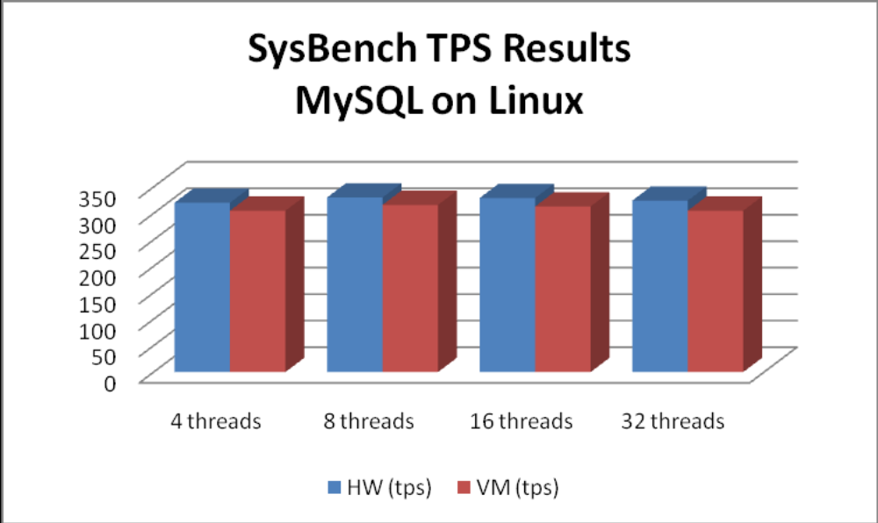

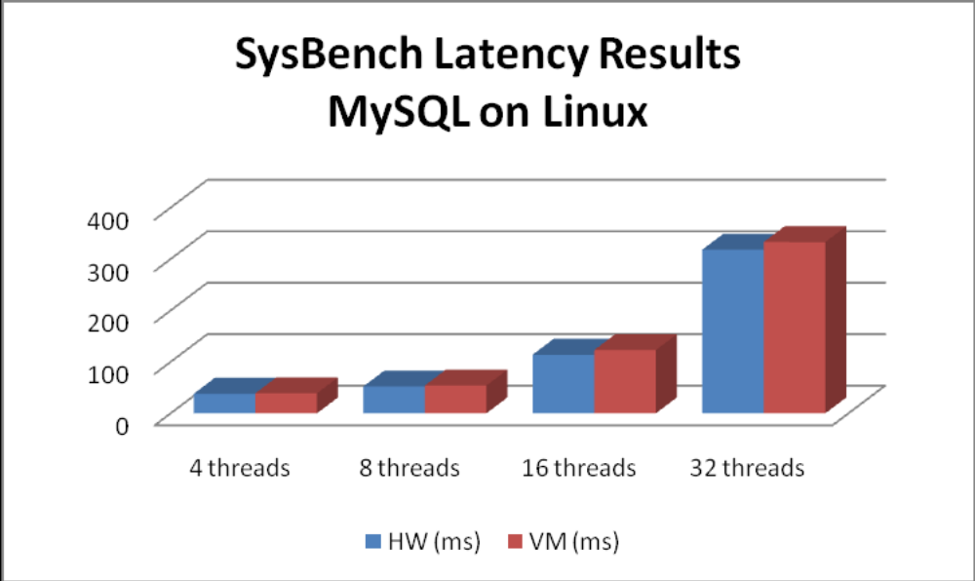

In case of our Mail Server firstly, OS needs to be installed through VMware vSphere wizard. Then once installed the Email Application can be installed as per normal installation.

Red Hat OS should be installed and run as it would be installed on a separate physical server as it’s fully compatible with VMware product.

VMware is designed to handle Windows Server 2003. In order to get its AD database running correctly on a virtual machine the following steps must be done:
- AD must be solid state backed up
- Correct data replication
- Time synchronization must be right
- Sufficient amount of RAM must be allocated depending on the amount of users
- Provide virtual machine access control

5.5 Schedule Feasibility.

The migration and configuration to virtual machine expected to be completed by the end of 2011

6. Cost and Benefits Analysis

This figure gives us an outline on the differences of the three solutions regarding the costs and the returns over a three year period.

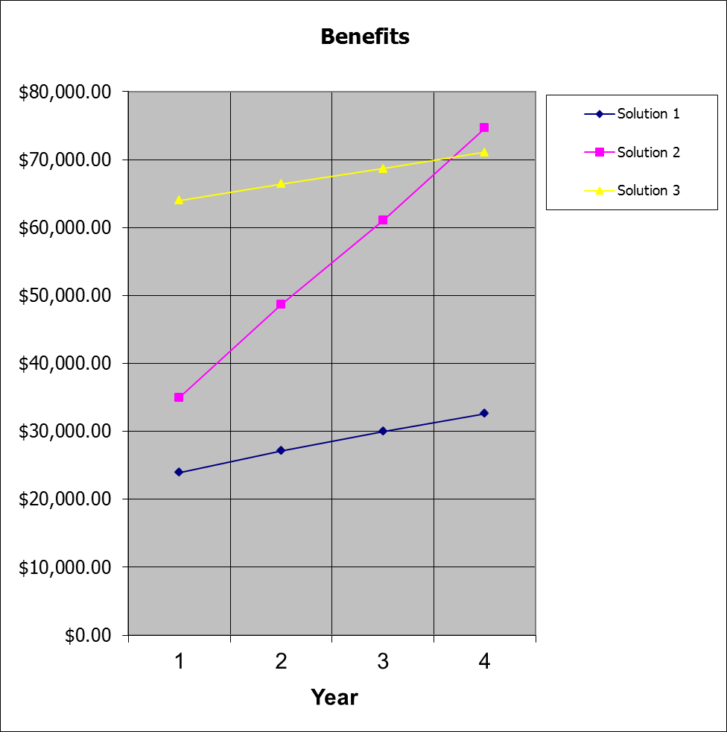

Solution 1 = blue/light blue
2 = pink/purple
3 = yellow/brown

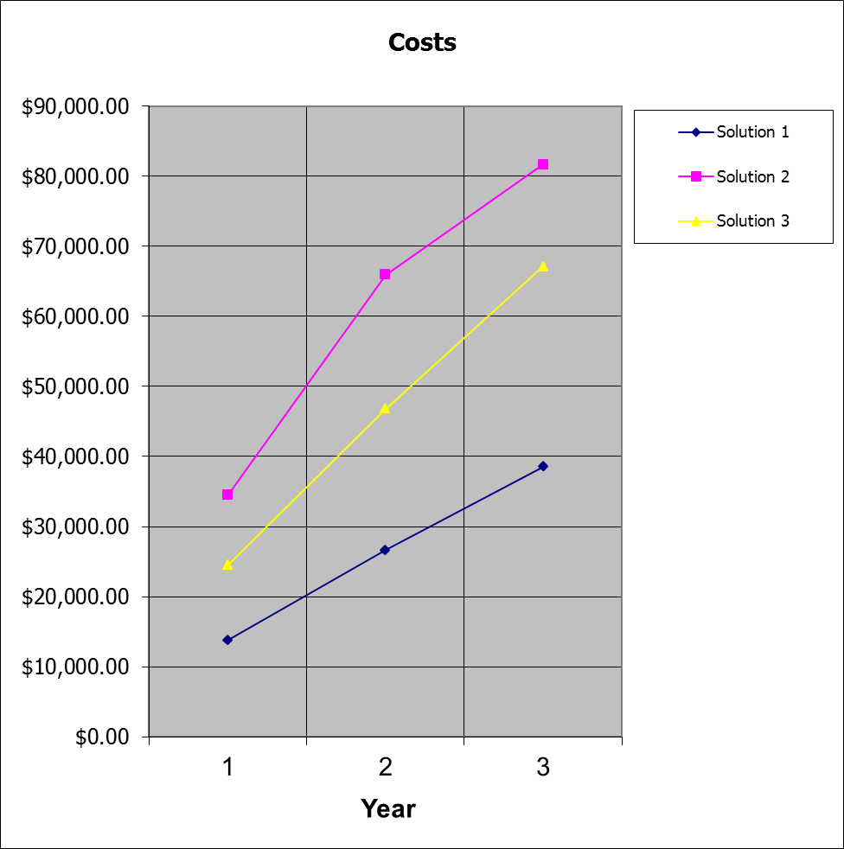

Solution 1 = blue/light blue
2 = pink/purple
3 = yellow/brown

7. Outline of approximate budget, timing and risks

Budget is estimated to be $49209.

$18,830 will be allocated to new hardware, i.e. procurement ether Dell or IBM proposed servers.

$19,193 will be allocated to installation, training and operating system cost.

$11,196 average recurring cost over the period of 3 years. That involves total software support and maintenance over that period, including updates and problem solving requests.

Procurement Cost | Nonrecurring Costs | Recurring costs x 3 year lifespan. | Total
$18,830 | $19,193 | $11,186.00 | $49,209.00

The following calculations outline the average TCO including average recurring
cost over the period of 3 years

- Timing - Must be finished by end of 2011 (all client computers and virtual machines migrated as well as data and user accounts and databases).

- Risks – Business continuity is the ability to minimize both scheduled and unscheduled downtime. That includes time lost to routine functions, such as maintenance and backup, as well as unanticipated outages. Hyper-V includes powerful business continuity features, such as live backup and quick migration, enabling businesses to meet stringent uptime and response metrics.

- Disaster recovery is a key component of business continuity. Natural disasters, malicious attacks, and even simple configuration problems like software conflicts can cripple services and applications until administrators resolve the problems and restore any backed up data. Leveraging the clustering capabilities of Windows Server 2008, Hyper-V now provides support for disaster recovery (DR) within IT environments and across data centers, using geographically dispersed clustering capabilities. Rapid and reliable disaster and business recovery helps ensure minimal data loss and powerful remote management capabilities.

8. Recommendation

The Hyper-v is highly recommended for its flexibility, availability and ease of use. The main benefits of this project are to save costs and minimal human intervention. Dealing with one physical machine will eliminate all the confusions and hassles on both administrative and end user prospective. It will benefit the institution, stakeholders as well as the environment.

Due to the existing Windows Server 2008 R2 Enterprise edition, we can utilize the licensing because it comes with hyper v plus 4 virtual machine licenses.

The IBM Server X5 3850 Series is the right hardware for this because of the following:

- Unmatched flexibility to meet changing workload demands
- Optimized systems with customizable configurations for target workloads
- Achieve greater performance and utilization at a lower total cost
- Keep consolidated workloads up and running with mainframe-inspired reliability
- Easy-to-own, simplified power and systems management

Hyper-V now provides support for disaster recovery (DR) within IT environments and across data centers, using geographically dispersed clustering capabilities. Rapid and reliable disaster and business recovery helps ensure minimal data loss and powerful remote management capabilities.

9. Appendices

9.1 Costs breakdown for solution 1 – VirtualBox.

9.1.1 Labour costs.
Breakdown of Labour costs.
Description | Time ($80 * 3)
Unpack server / dispose of packaging / assembling |  | 2 hours
Hardware diagnostic on new hardware |  | 8 hours
Install / configure virtualisation host operating system. |  | 5 hours
Testing virtualisation host operating system. |  | 8 hours
Install and configure VirtualBox containers x4 |  | 4 hours
Install base Windows O/S in virtual containers x 3 |  | 9 hours
Install base Fedora Linux in virtual containers |  | 1 hour
Diagnostic on installed virtualised O/S' |  | 8 hours
Configure PDC on vws1 (virtual windows server1) |  | 2 hours
Install configure Exchange server |  | 2 hours
Configure file shares |  | 2 hours
Install configure MS SQL 8 server |  | 2 hours
Configure Linux guest <-> windows guest interaction |  | 1 hour
Diagnostic test on configured virtual systems |  | 8 hours
Migrate user data to virtual file server |  | 8 hours
Migrate user accounts to virtual file server |  | 4 hours
Migrate exchange data |  | 8 hours
Migrate SQL server data |  | 4 hours
Test live data in lab environment |  | 8 hours
Decommission existing servers |  | 4 hours
Commission new server |  | 4 hours
Server post-deployment assistance. |  | 8 hours / $26,400.00
Training |  | 12 hours / $2,880.00
Total |  | 122 hours / $29,280.00

9.1.2 Hardware costs.
Breakdown of VirtualBox virtual host server costs.
Item Description | Price
PowerEdge T310 Tower Chassis for Up to 4x 3.5" Hot Plug HDDs with LCD Diagnostics (included in price) | $0 (included in base system price)
Intel Xeon X3430 Xeon CPU, 2.4GHz, 8M Cache (Included in Price) | $0 (included in base system price)
8GB Memory (4x2GB), 1333MHz, Dual Rank UDIMMs ([Included in Price) | $0 (included in base system price)
C16 Hot-Swap ASS No RAID for SAS6iR/PERC H200, Min. 1 Max. 4 SAS/SATA/SSD Hot Plug Drives (Included in Price) | $0 (included in base system price)
SAS 6/iR Internal Controller for Hot Plug HD Configuration (Included in Price) | $0 (included in base system price)
$0 (included in base system price) | $0 (included in base system price)
Base system price | $2099.00
800/1600GB LTO4 Half High Internal Tape Drive | $3660.80
Dell(TM) WORM Data Cartridge (1-Pack) for LTO4 | $224.40
Dell UPS Tower 1000W 230V | $493.90
Dell(TM) E170S Entry 17 " Flat Panel LCD Monitor | $238.70
Dell(TM) USB 104-key Standard Black Keyboard | $35.20
Dell(TM) Optical USB Black Mouse | $16.50
3 Yrs Next Business Day Onsite Service | $684.20
250GB 7.2K RPM SATA 3.5 " Hot Plug Hard Drive x 2 | $272.80
2TB 7.2K RPM SATA 3.5 " Hot Plug Hard Drive x 2 | $1170.40
Total | $7,490.10

9.1.3 Software costs (If existing licenses cannot be transferred)
Operating systems cost.
Microsoft Windows Server 2008 x 3 | $10,845
Redhat Fedora | $0
Redhat | $799
Oracle Virtualbox x 4 | $0
Transfer MS SQL | $0
Transfer Exchange | $0
Total | $11,644.00

9.2 Costs breakdown for solution 2 – Hyper-V.

9.2.1 Labour costs.
Breakdown of Labor costs.
Description | Time ($80 * 3)
Unpack server |  | 2 hours
Hardware diagnostic on new hardware |  | 8 hours
Install / configure virtualization host OS |  | 5 hours
Testing virtualization host operating system. |  | 8 hours
Install and configure virtual box containers x4 |  | 4 hours
Diagnostic on installed virtualized O/S' |  | 8 hours
Configure Exchange server |  | 3 hours
Configure file shares |  | 2 hours
Install configure MS SQL 8 server |  | 2 hours
Diagnostic test on configured virtual systems |  | 8 hours
Migrate user data to virtual file server |  | 8 hours
Migrate user accounts to virtual file server |  | 4 hours
Migrate exchange data |  | 8 hours
Migrate SQL server data |  | 4 hours
Test live data in lab environment |  | 8 hours
Decommission existing servers |  | 4 hours
Commission new server |  | 4 hours
Server post-deployment assistance. |  | 8 hours
Training over 3 months period |  | 58.25 hours
Total Hours |  | 156.25 ($80*3)
Total Amount |  | $25,000.00

9.2.2 Hardware costs.

Breakdown of Hyper-V virtual host server costs.
Base system total price | $25,000.00
IBM System x3850 X5 71451RU | $10,685.00
5 Year Onsite Repair 24x7 2 Hour Response 84Y2242 | $4,770.00
Remote Technical Support for System x - Base - 1 yr 96P2703 | $665.00
Additional (expansion slots for memory, hard drive, PCI Slots and OEM Licenses) | $8880.00
Intel® Xeon™ Processor E7520 4C / 1.86GHz | $0 Included
Memory 16GB/ 1024GB/DDR3  standard Hard Disk 4TB | $0 Included
4U Rack | $0 Included
Three year parts and labor | $0 Included
16x DVD-ROM Drive | $0 Included

9.2.3 Software costs

OEM software included in the hardware costs table above.

9.3 Costs breakdown for solution 3 – VMware.

10. Glossary

CSV – cluster shared volume
CAL – client access licenses
OSE – operating system environment
OEM – original equipment manufacturer
SQL – structured query language
VHD – virtual hard disk
VM – virtual machine

11. References

http://itmanagement.earthweb.com/netsys/article.php/3717181/Hardware-for-Virtualization-Dos-and-Donts.htm
http://www.virtualbox.org/wiki/Migrate_Windows
http://www.elmajdal.net/Win2k8/Migrating_Active_Directory_Domain_Controller_from_Windows_Server_2003_to_Windows_Server_2008.aspx
http://support.microsoft.com/kb/314546
http://www1.ap.dell.com/au/en/business/servers/server-poweredge-t310/pd.aspx?refid=server-poweredge-t310&s=bsd&cs=aubsd1
http://www.globalsources.com/manufacturers/17-LCD-Power-Consumption.html
http://virtualizationstuff.blogspot.com/2008/01/actual-roi-of-virtualization.html
http://download.microsoft.com/download/4/e/3/4e3eace0-4c6d-4123-9d0c-c80436181742/oslicqa.doc
http://www.linux.org/info/gnu.html
http://fedoraproject.org/wiki/Legal/Licenses/LicenseAgreement13
https://www.redhat.com/licenses/Enterprise_Agr_Australia.pdf
www.vmware.com

http://www.mysql.com/why-mysql/white-papers/mysql_wp_VMware_BestPraticesandPerfGuidev7.php

http://www.microsoft.com/windowsserver2008/en/us/hyperv-main.aspx
http://en.wikipedia.org/wiki/
http://www.directionsonmicrosoft.com/sample/DOMIS/update/2008/02feb/0208ws2plp.htm
http://www.microsoft.com/windowsserver2008/en/us/hyperv-faq.aspx
http://www-304.ibm.com/shop/americas/webapp/wcs/stores/servlet/default/CategoryDisplay?catalogId=-840&storeId=1&langId=-1&categoryId=4611686018425279711
http://docs.hp.com/en/A3725-96021/ch02s02.html

